**Test tasks Flex Databases:**

1. Read the requirements and review the form on page 3. Describe any defects and inaccuracies that are present in the assignment and implementation. The defect description form is free. Fill in the severity of each defect. (Blocker, Critical, Major, Minor, Trivial). Design a testing checklist to verify the listed requirements.

Tracking and Monitoring module.

4.5 Flow 4: Protocol Design Creation

|  |  |  |  |
| --- | --- | --- | --- |
| **UR ID** | **FR ID** | **FR Specification** | **FR Priority** |
| **PDC** | **Flow 4: Protocol Design Creation** | |  |
| [U-PDC-01](https://confluence.flexdbs.com/requirements/STI/U-PDC-01) | [F-PDC-001](https://confluence.flexdbs.com/requirements/STI/F-PDC-001) | The System shall provide Protocol Design tools accessf for users with following role:   * Manager * Specialist | H |
|  | ***Study Parts*** | |  |
| [U-PDC-02](https://confluence.flexdbs.com/requirements/STI/U-PDC-02) | [F-PDC-002](https://confluence.flexdbs.com/requirements/STI/F-PDC-002) | The System shall allow the user to create/edit study part record using the following **mandatory** parameter:   * * Study part name [Boolean, 256 symbols] * * Version [text, 256 symbols] | H |
| [U-PDC-02](https://confluence.flexdbs.com/requirements/STI/U-PDC-02) | [F-PDC-003](https://confluence.flexdbs.com/requirements/STI/F-PDC-003) | The System shall allow the user to create/update the study part record only if the study part name is unique within the study part list. | L |
| [U-PDC-02](https://confluence.flexdbs.com/requirements/STI/U-PDC-02) | [F-PDC-004](https://confluence.flexdbs.com/requirements/STI/F-PDC-004) | If the study part name was changed, the System shall automatically apply this change to all datasets where this study part is in use. | M |
| [U-PDC-02](https://confluence.flexdbs.com/requirements/STI/U-PDC-02) | [F-PDC-005](https://confluence.flexdbs.com/requirements/STI/F-PDC-005) | The System shall allow the user to delete the study part if there is no visit group connected with this study part. | M |
| [U-PDC-02](https://confluence.flexdbs.com/requirements/STI/U-PDC-02) | [F-PDC-006](https://confluence.flexdbs.com/requirements/STI/F-PDC-006) | If the study parts have been created, the System shall display the study parts in the same order as specified in the study parts list in the following interfaces:   * -Visit group list -Visit list * -Visit schedule * -Study budgets * -Site budget documents -Subject schedule | K |
| [U-PDC-02](https://confluence.flexdbs.com/requirements/STI/U-PDC-02) | [F-PDC-007](https://confluence.flexdbs.com/requirements/STI/F-PDC-007) | The System shall allow the user to change the order of the study part records within the list of study parts available in the grid. | L |

Defects

|  |  |  |  |  |
| --- | --- | --- | --- | --- |
| ID | Summary | Actual | Expected | Severity |
| 1 | Wrong data type in FR Specification F-PDC-002 | Study part name parameter is described as "boolean, 256 symbols". | Data type and length corresponds to expected text data: [Text, 256 symbols]. | Blocker |
| 2 | Different font in FR Specification F-PDC-005 | The font of the text, describing FR Specification F-PDC-005 is Century Gothic, the rest of document is Times New Roman. | Font is the same for all the document. | Trivial |
| 3 | Missing mandatory parameter "Version" in Study Parts module when creating/editing record. | Study Parts module has only field "name" when creating/editing record. Mandatory parameter "Version" isn`t present. | Both mandatory parameters have fields to be filled during creating/editing records. | Major |
| 4 | Incomplete field description in Study Parts module when creating/editing record. | When adding a new Study Part record, the field has a description "study part" without a designation of name, version or any other data should be entered | A field has a unambiguous and complete description. | Minor |

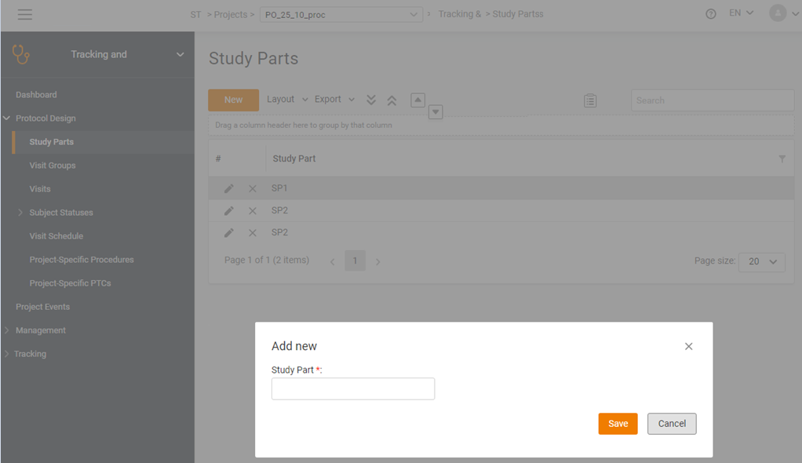

Checklist:

|  |  |  |  |
| --- | --- | --- | --- |
| Protocol Design tool | | | |
| № | Priority | Test | Result |
| 1 | High | Access by Manager | Yes |
| 2 | High | Access by Specialist | Yes |
| 3 | High | Access by user | No |
| 4 | High | Access by unauthorized | No |
| Study Parts | | | |
| 5 | High | Study part name =< 256 sym | Yes |
| 6 | High | Study part Version =< 256 sym | Yes |
| 7 | High | Study part name > 256 sym | No |
| 8 | High | Study part Version > 256 sym | No |
| 9 | Low | Study part name is unique within list | Yes |
| 10 | Middle | Autoshange dependent datasets on Study part rename | Yes |
| 11 | Middle | Removable Study part if no visit group connected | Yes |
| 12 | High | Order of display Study parts in: | Same as in Study part list |
| • Visit group list -Visit list |
| • Visit schedule |
| • Study budgets |
| • Site budget documents -Subject schedule |
| 13 | Low | Study part records in list are sortable by user | Yes |

1. Describe all possible cases that can be checked in this form: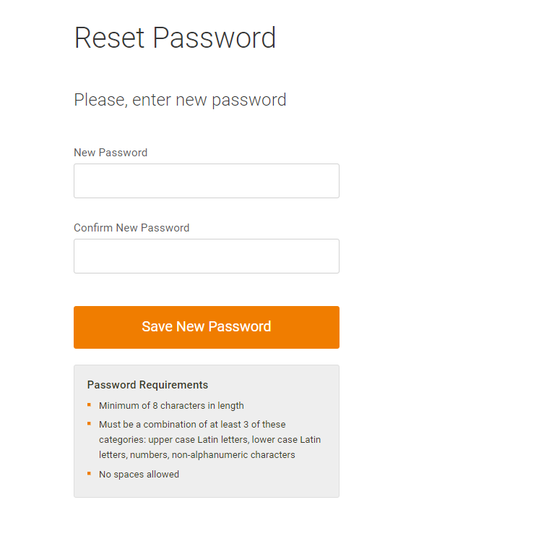Suppose an error was found in one of the cases of the previous assignment (of your choice). Describe (in English) the bug that the developer will understand.

|  |  |  |
| --- | --- | --- |
| Length | | |
| № | Check | Result |
| 1 | Enter 8 characters | OK |
| 2 | Enter 256 characters | OK |
| 3 | Enter 7 characters | Error message |
| 4 | Enter 1000 characters | Error message |
| 5 | Enter 1 character | Error message |
| 6 | Do not enter any symbols, empty field | Error message |
| Content | | |
| 7 | Latin characters in upper and lower case, numbers, non-alphanumeric characters | OK |
| 8 | Latin characters in upper and lower case, numbers | OK |
| 9 | Latin characters in upper and lower case, non-alphanumeric characters | OK |
| 10 | Uppercase Latin characters, numbers, non-alphanumeric characters | OK |
| 11 | Lowercase Latin characters, numbers, non-alphanumeric characters | OK |
| 12 | The data in both fields is the same | OK |
| 13 | The entered characters are displayed as asterisks | OK |
| 14 | Only two of four character types, described in test 7 are entered | Error message |
| 15 | Spaces | Error message |
| 16 | Executable code | Error message |
| 17 | Non-latin characters | Error message |
| Misc | | |
| 18 | The data in the fields does not match | Error message |
| 19 | The entered characters are displayed as text | NO |
| 20 | Input characters are not displayed | NO |
| 21 | Fields are filled in correctly | The "Save New Password" button is active, highlighted in color, the data is sent. |
| 22 | The fields are filled incorrectly | The button is inactive, blurred. |

Bug report.

|  |  |  |  |  |
| --- | --- | --- | --- | --- |
| ID | Description | STR | Actual | Expected |
| 1 | Spaces are accepted in "New Password" and "Confirm New Password" fields, when password is entered by key combination CTRL+V | 1. Write a valid password in text editor, add a space character at the end of word.  2. Copy password with space in clipboard  3. Paste in "New Password" and "Confirm New Password" fields by key combination CTRL+V. | 1. System accepts entered space symbols, no error message displayed. | System displays an error message, new password is not accepted. |

1. Write (in English) an understandable and not very large specification, describing the mechanical pen functionality.

Considering the initial task data only describe that the pen is mechanical, the following assumptions were used to create the specifications:

• The pen can be disposable, or have an exchangeable writing unit/barrel.

• The handle mechanism can be rotary or spring-loaded.

• A pen can contain one or more different colored writing units.

• The handle is not intended for use in extreme conditions: under water, at temperatures below -15°C and above +45°C, in vacuum, in microgravity, etc.

• The pen is designed for writing on paper and paper-like materials. Glass, metal, polymers, and materials with high porosity are not considered.

• The pen is intended for a user who has no physical, mental, or other conditions affecting its use.

**Functional requirements:**

1) In working state, the pen leaves an even, clear, continuous mark on the paper.

2) Line width is 0.5-0.7mm

3) The writing unit in the working position should not move during writing.

4) In an inoperative state, the mechanism allows to completely hide the writing unit.

5) In an inoperative state, under normal circumstances the outflow of pigment is excluded.

6) The length of the continuous writing line (without refill) is at least 2500m.

7) The mechanism should ensure reliable bringing into the working position of the writing unit and its return to the non-working position.

8) The resource of the mechanism must be at least 23000 cycles, for pens with more than one writing unit - at least 15000 cycles.

**Non-functional requirements:** (just in case)

1) The pen body allows user to unambiguously and securely hold the pen when writing, both with the right and left hand.

2) Pen`s shape and size should be ergonomically designed so as to result in a comfortable writing experience. Weight and dimensions should allow continuous use of the pen for 3 hours without a feeling of physical fatigue from the user.

3) The pigment does not change its color both inside the writing unit and on paper for at least 1 year.

4) Pen and pigment materials are harmless for health in use and storage.

5) Pens with more than one writing unit must have pigment color indicators.

6) After a free fall of the pen from a height of 1 m, there should be no destruction of the pen parts that affects its intended use.

7) The tip of the writing unit in the working position should stand out from the pen body by 1.5 mm, not less.

8) The cap of the pen must not fall off under its own weight.

9) Actuation of the rotary mechanism of the pen writing unit must be provided with a torque of no more than 0.16 N•m, for the other mechanisms - with a force of no more than 6.0 N.

10) The bending strength at the joints of the pen must be at least 50 N under static loads.

11) The joints of the body parts of the handle should not be destroyed when a static axial force of no more than 50 N and a torque of no more than 1.0 N•m are applied.

12) External metal parts of handles must be made of corrosion-resistant metals and (or) have a protective and decorative coating.

13) In case the holder is combined with the extension mechanism, the holder resource must be no less than the extension mechanism`s one. The resource of the holder must be at least 2000 bends.

14) The appearance of the pen must correspond to the reference sample.

15) The pens in package must withstand the impact of transport shaking, as well as temperatures from -15 °С to +45 °С.

1. Postal rates for "light letters" are 25p up to 10g, 35p up to 50g plus an extra 10p for each additional 25g up to 100g. Which test inputs (in grams) would be selected using equivalence partitioning?

1) 8, 42, 82, 102

**2) 4, 15, 65, 92, 159**

~~3~~*~~) 10, 50, 75, 100~~*

4) 5, 20, 40, 60, 80